**Exercitiul nr.1**

x1=linspace(-pi, pi, 50)

y1=x1.^2+4.*sin(2.*x1)-1

x2=linspace(-pi, pi, 50)

y2=2.*x2+8.*cos(2.*x2)

x3=linspace(-pi, pi, 50)

y3=2-16.*sin(2.*x3)

plot(x1, y1, x2, y2, x3, y3)

title('Functia f1 si derivatele de ordinul intai si doi')

legend('functia f1', 'derivata de ordinul intai', 'derivata de ordinul doi')

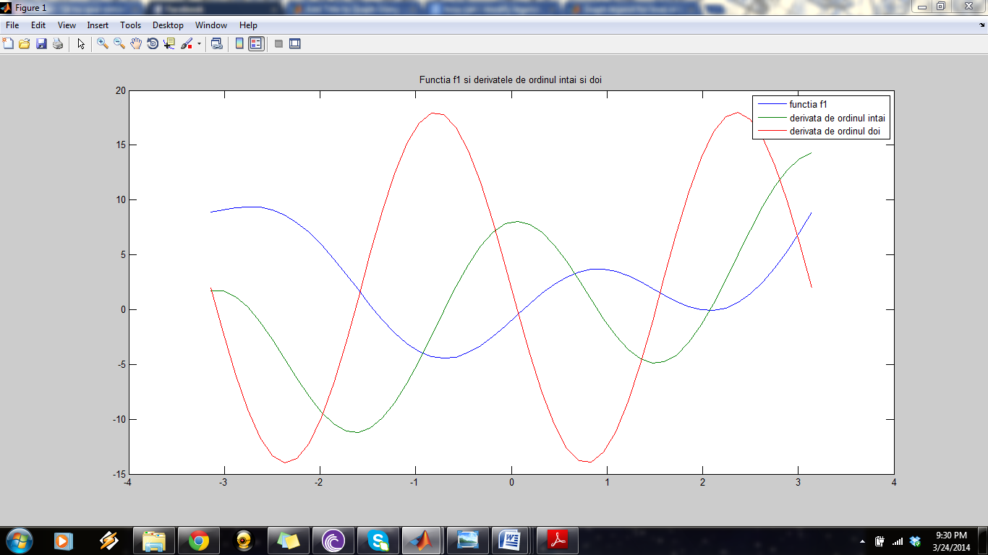

**Exercitiul nr.2**

x=linspace(-10, 10, 50)

y=(x.^2-x+1)./(x.^2+x+1)

plot(x, y)

title('functia f2')

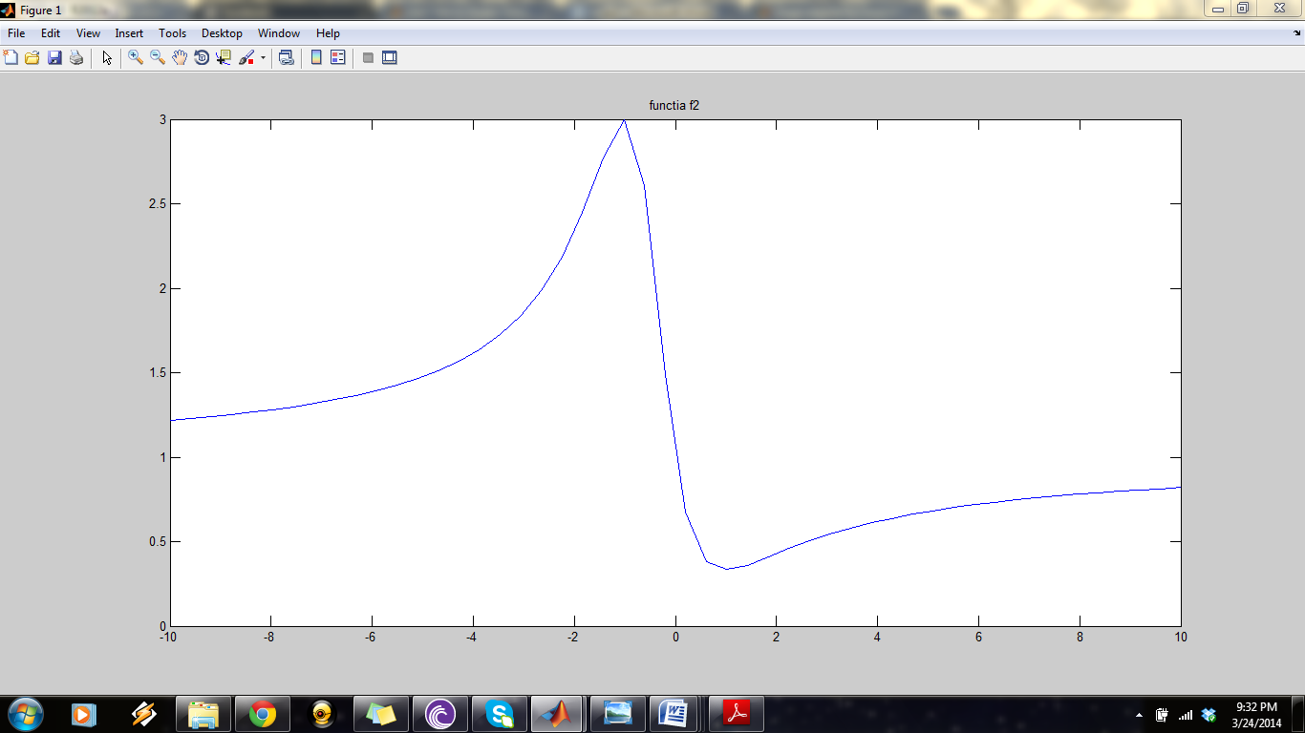

**Exercitiul nr. 3**

x1=linspace(0, 2*pi, 50)

y1=3.*x1.*sin(x1)-2.*x1

x2=linspace(0, 2*pi, 50)

y2=3.*x2.*cos(x2)+3.*sin(x2)-2

x3=linspace(0, 2*pi, 50)

y3=6.*cos(x3)-3.*x3.*sin(x3)

plot(x1, y1, x2, y2, x3, y3)

title('Functia f3 si derivatele de ordinul intai si de ordinul doi')

legend('functia f3', 'derivata de ordin intai', 'derivata de ordin doi')

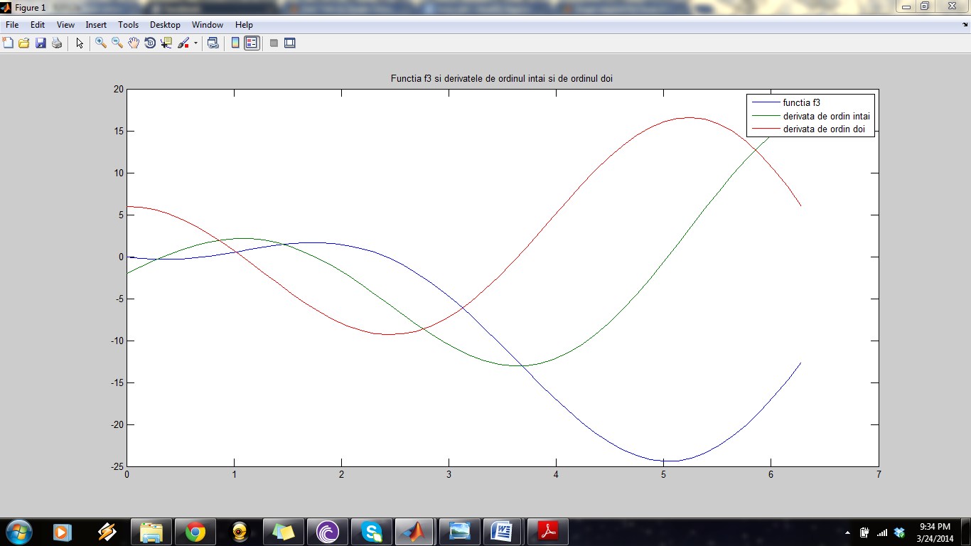

**Exercitiul nr. 4**

function [ y ] =f1( x )

%UNTITLED7 Summary of this function goes here

% Detailed explanation goes here

y=x^2+4*sin(2*x)-1

end

function [ y ] = f2( x )

%UNTITLED8 Summary of this function goes here

% Detailed explanation goes here

y=(x^2-x+1)/(x^2+x+1)

end

x=linspace(-5,5,100);

for i=1:100

y(i)=f1(x(i))

end;

x1=linspace(-5,5,100);

for i=1:100

y1(i)=f2(x(i))

end;

hold on

plot(x,y,'r','LineWidth',2);

grid on

plot(x1,y1,'b','LineWidth',2);

hold off;

legend('graficul lui f1','graficul lui f2');

title('graficele functiilor f1 si f2')

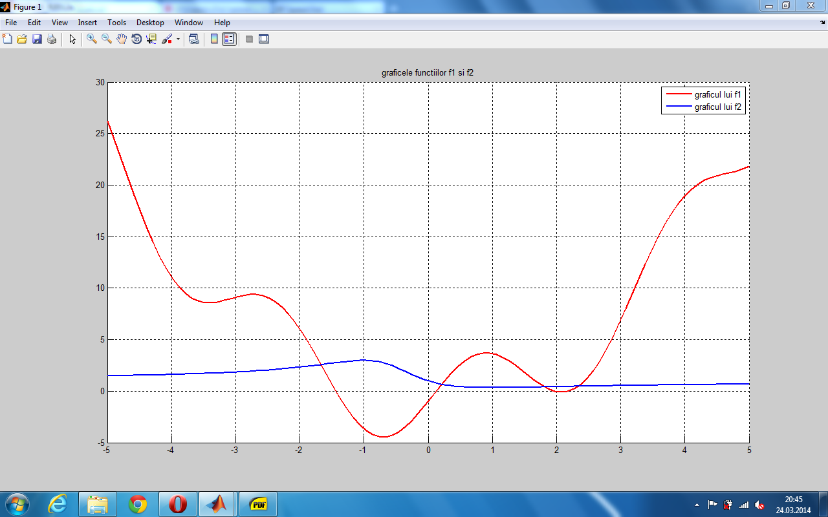

**Exercitiul nr. 5**

function [ y] = fun( x )

%UNTITLED10 Summary of this function goes here

% Detailed explanation goes here

if x>-2 & x<0;

y=x.^2

elseif x>=0 & x<3;

y=x.^3

elseif x>=3 & x<4;

y=x.^2+18

else y=0

end

x=linspace( -5,5,100);

for i=1:100

y(i)=fun(x(i));

end

plot(x,y);

